MAY DEVINEY
NO AI, ONLY I
June 23–July 11, 2026

OPENING RECEPTION
Thursday, June 25, 2026 | 6–8 PM

CLOSING RECEPTION
Saturday, July 11, 2026 | 4–6 PM

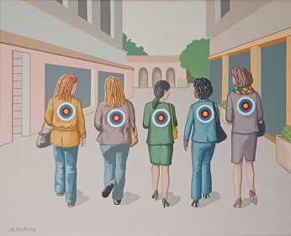 | 1. As It Once Was, Does It Have to Be Again?  2024  Acrylic and collage on canvas  16 x 20 in. | $1,400
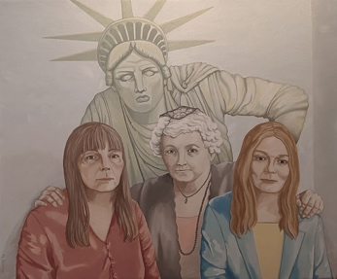 | 2. Comrades  2026  Oil on canvas  35 x 42 in. | $3,500

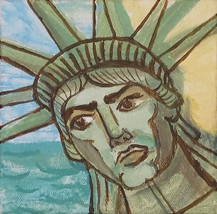 | 3. The Lady is Worried  2024  Acrylic on canvas  6 x 6 in. | $150
 | 4. Noir Scene: Come and Get Me, Coppers!  2023  Acrylic, watercolor, and ink stamping  10.25 x 14.25 in. | $350
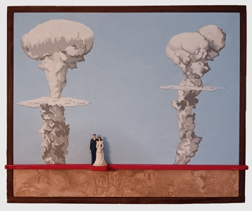 | 5. Married Between Two Bombs: The Story of Ken and Ruby  2006  Acrylic on canvas, wood, plastic, and brass  30 x 36 x 3 in. | NFS
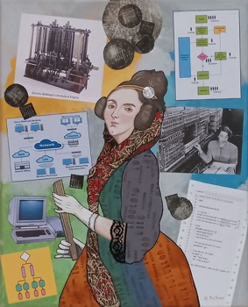 | 6. Ada Lovelace, The First Computer Programmer  2024  Acrylic on canvas with collage  20 x 16 in. | $500
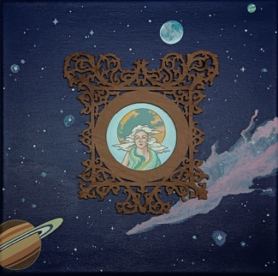 | 7. Gaia  2025  Acrylic on canvas with found wood overlay  12 x 12 x 1 in. | $450
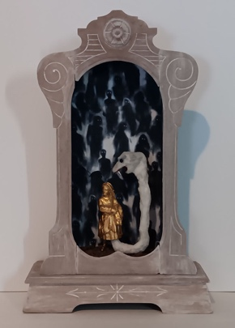 | 8. The Haunting  2026  Metal figure, cloth, tree bark, wire, beads, gauze, and acrylic in an antique clock case  19.75 x 12.5 x 4.25 in. | $750
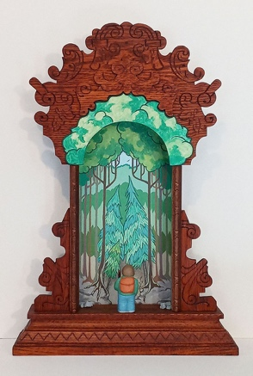 | 9. Forest Trekker  2023  Acrylic on canvas, illustration board, polymer clay, stones, wood, and fabric on an antique clock case  22 x 15 x 5 in. | $1,600
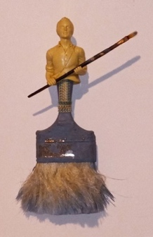 | 10. Art is the Handmaid of Human Good  2023  Bottle topper, used artist brush, and ribbon on a  used house paint brush  13 x 7 x 2 in. | $140
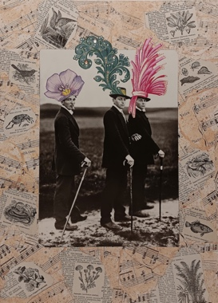 | 11. Spring Finery  2025  Paper collage with jewels  14 x 10 (unframed)  16.5 x 12.5 (framed) | $150
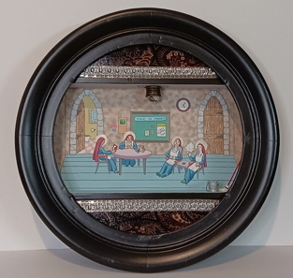 | 12. Last Supper Support Staff on Break  2025  Acrylic and mixed media on an antique clock cabinet  17.25 x 17.25 x 3.75 in. | $800
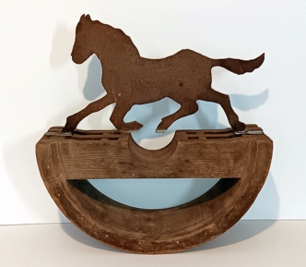 | 13. Mill City Equus  2026  Antique metal and an old mill pulley wheel  17 x 16 x 6.5 in. | $550
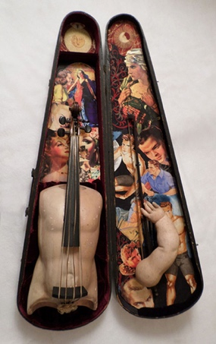 | 14. The Savage Breast  2013  Antique doll parts and violin arts, antique violin case,  paper and fabric collage, wood, and synthetic hair  31 x 18 x 5 in. | $1,200
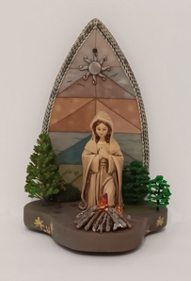 | 15. Scorched Madonna: Camping  2026  Watercolor on canvas (scorched), acrylic, wood, plastic, braiding, and metal  9.25 x 6.25 x 5 in. | $250
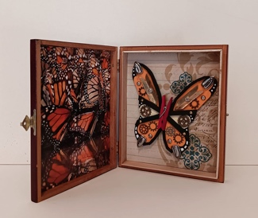 | 16. Iron Butterfly  2024  Paper, wood, metal, miniature irons, and acrylic in a found cigar box  7 x 5.75 x 1 in. (Closed)  10 x 7 x 4 in. (Open) | $165
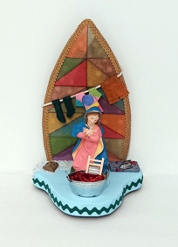 | 17. Scorched Madonna: In the Laundry  2026  Watercolor on canvas (scorched), acrylic, wood, plastic, braiding, and metal  9.25 x 6.25 x 5 in. | $250
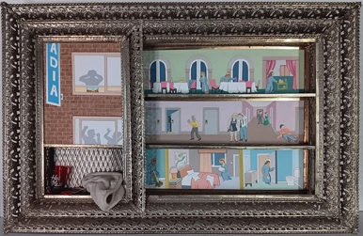 | 18. The Party Hearty Hotel  2026  Acrylic and graphite on board, glass, and fabric  in an antique shadowbox  20.5 x 32 x 3.5 in. | $1,700
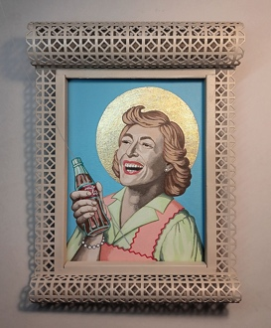 | 19. Lunch Lady Madonna  2024  Acrylic on canvas over wood, foil leaf, and an antique frame  15 x 13 x 5 in. | $950
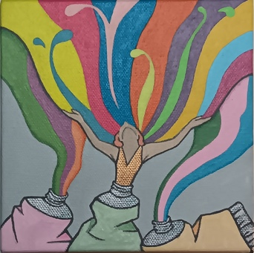 | 20. The Joy I Get From Art  2023  Acrylic on canvas  6 x 6 in. | $150
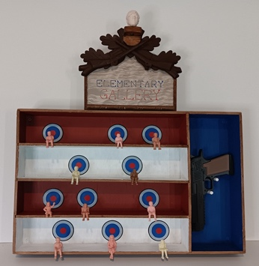 | 21. Elementary Gallery  2026  Acrylic, plastic, wood, and an antique cutlery drawer  22.25 x 20 x 3.25 in. | $800
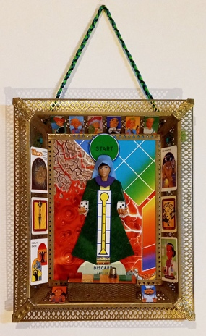 | 22. Gameboard Madonna  2024  Gameboards and cards, tokens, vintage frame,  GI Joe hands, wood, dice, and shoelaces  17 x 14 x 2 in. | $650
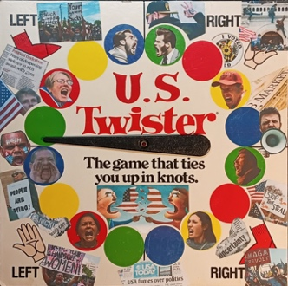 | 23. U.S Twister  2025  Acrylic and collage on a Twister game spinner board  12.75 x 12.75 x 1.75 in. | $150
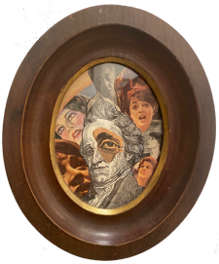 | 24. (He Who Wants to Be) Master  2016  Collage with antique frame  7 x 6 in. (framed) | $150
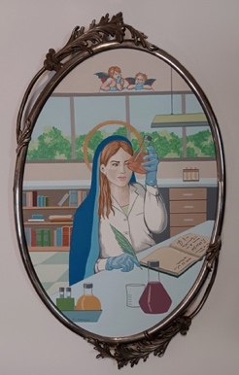 | 25. Scientist Madonna  2026  Acrylic on canvas over wood on an antique clock frame  23.5 x 14 in. | $1,600
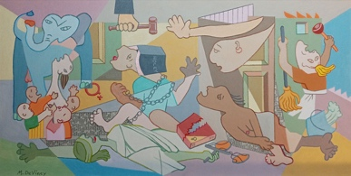 | 26. She-uernica  2026  Oil and newspaper on canvas  60 x 28 in. | $4,000

